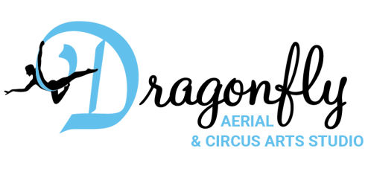
4506 Fennel Rd, Knoxville, TN 37912
dfaas11@gmail.com
www.dragonflyaerialartsstudio.com
865-609-2012

Tuition Assistance Form

This application form is for assistance resulting in the reduced price ($35 for 4 weeks, $50 for six weeks) session of kids classes.

Student’s Name ___________________________________________________Date _______________
Birth Date _________________________________ Phone ____________________________________
Address _____________________________________________________________________________
Class(es) ____________________________________________________________________________

Reason For Application: (Describe situation resulting in request for financial assistance.)
___________________________________________________________________________________
___________________________________________________________________________________
___________________________________________________________________________________
___________________________________________________________________________________
___________________________________________________________________________________

For dependent child please provide the following information:
Father’s Name _______________________________________________________________________
Home Address _______________________________________________________________________
Occupation _____________________________________ Employer ____________________________
Years Employed _________________________________ Business Phone _______________________

Mother’s Name _____________________________________________________________________
Home Address _______________________________________________________________________
Occupation _____________________________________ Employer ____________________________
Years Employed _________________________________ Business Phone _______________________

List any additional information that should be considered:
_____________________________________________________________________________________
_____________________________________________________________________________________

This information contained in this application is provided for the purpose of obtaining financial assistance from Dragonfly Aerial and Circus Arts Studio (Dragonfly) for tuition. I (we) understand that Dragonfly is relying on this information in deciding to grant tuition assistance. I (we) represent and warrant that the information provided is true and complete.
______________________________________ ___________________________________
Signature Date
______________________________________ ___________________________________
Signature Date

